**Assignment 2 – Tableau**

**Solution 1.**

**Solution 2.**

Total number of **tables** in the loaded dataset – **3**

Total number of **rows** in the Orders table – **10,194**

Total number of **columns** in the Orders table – **21**

**Solution 3**

**Relationship:** Orders – People

**Relationship:** Orders – Returns

**Solution 4**

**Solution 5**

**b) Sum**

**Solution 6**

**Solution 7**

* When aggregation was changed from sum to average, the magnitude of the data on the y-axis considerably shrank.
* When aggregation was switched from sum to average, the bar representing Office Supplies likewise fell off dramatically.

**Solution 8**

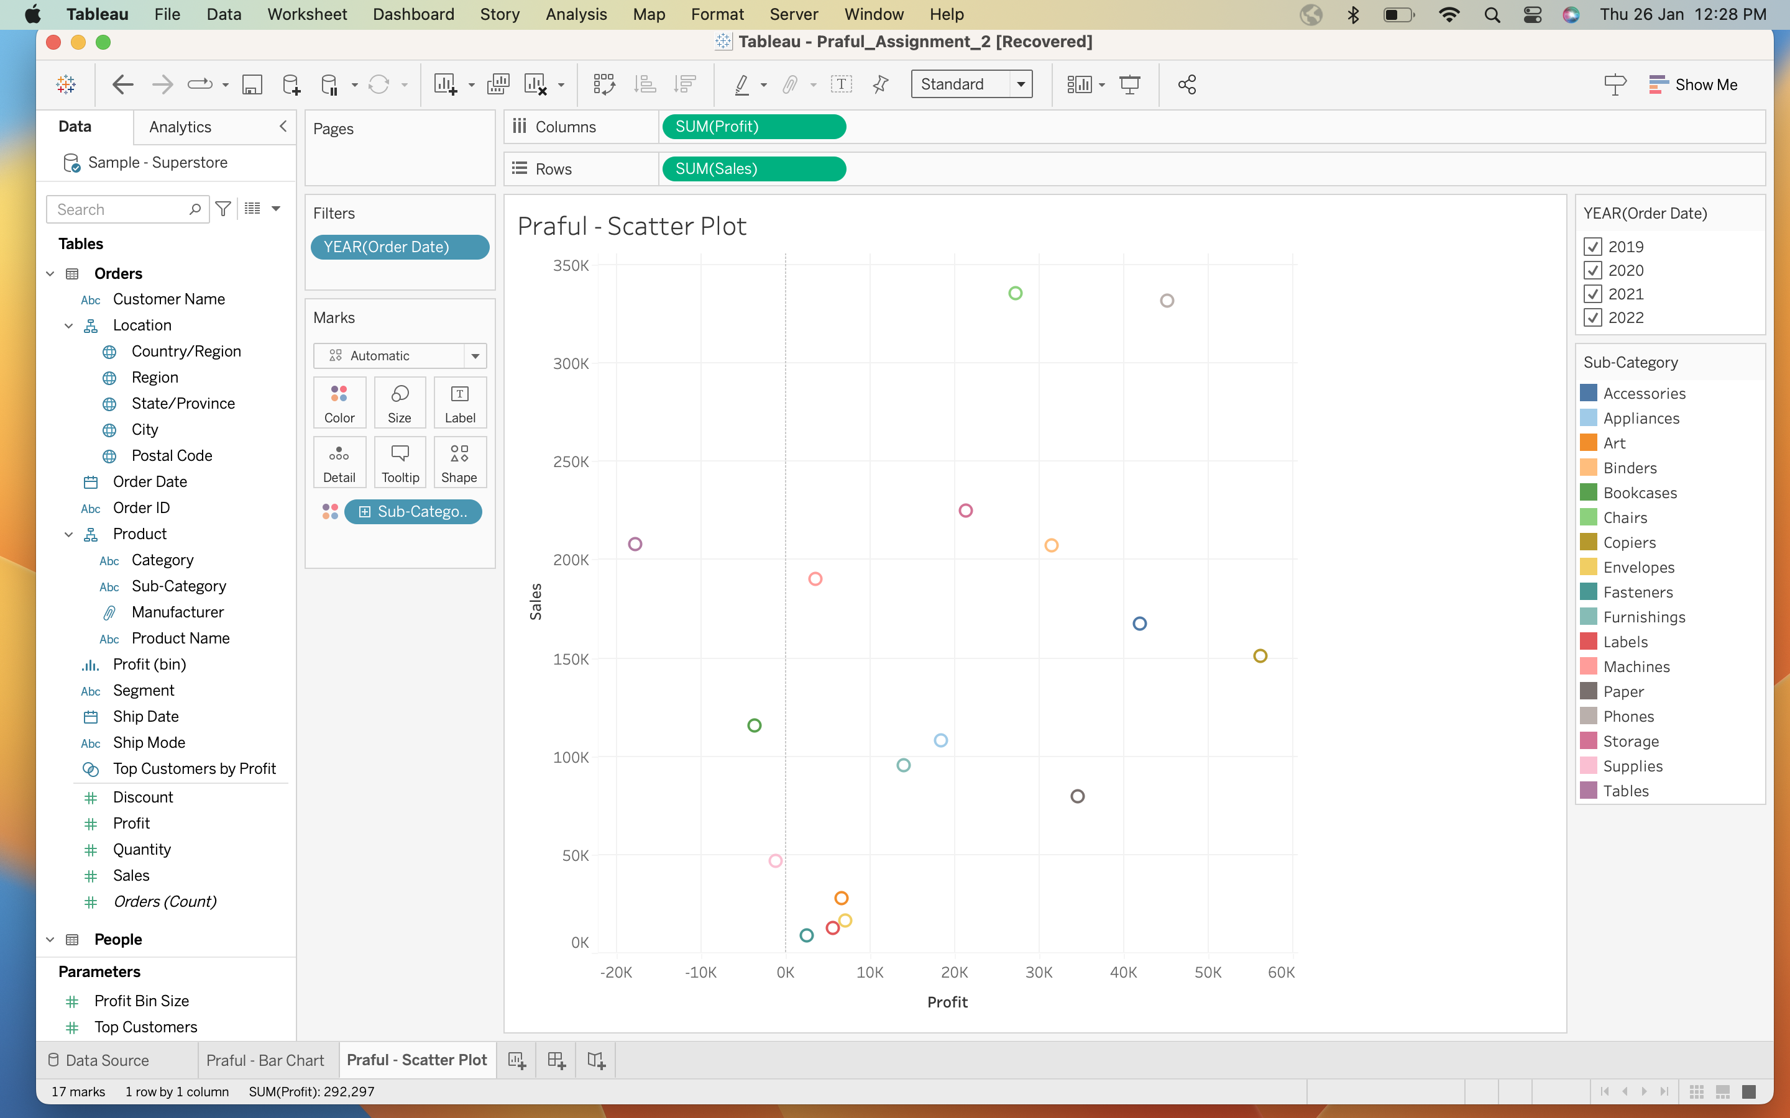

**Solution 9**

Sub-categories with **sales** greater than $140,000:

1. Chairs
2. Phones
3. Storage
4. Tables
5. Blinders
6. Machines
7. Accessories
8. Copiers

Sub-categories with **profit** greater than $10,000:

1. Furnishings
2. Appliances
3. Storage
4. Chairs
5. Blinders
6. Paper
7. Accessories
8. Copiers
9. Phones

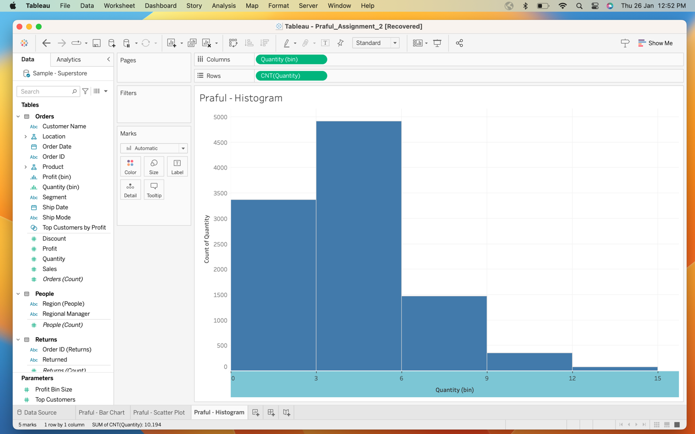**Solution 10**

**Solution 11**

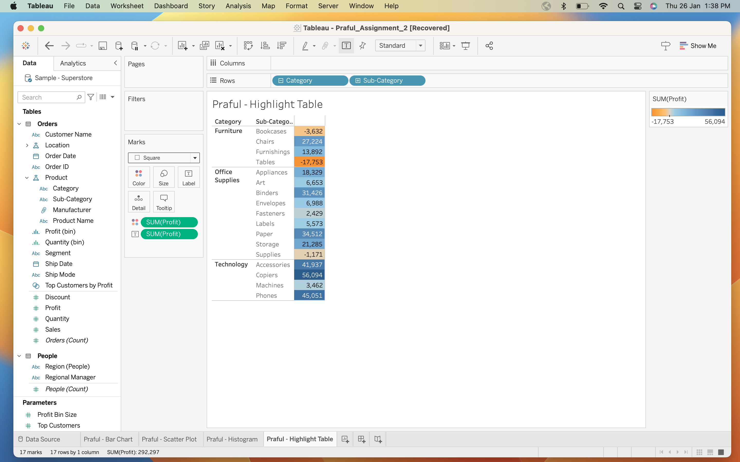

**Solution 12**

Sub-categories making the **most profit**:

* Copiers $56,094
* Phones $45,051
* Accessories $41,937

Sub-categories making the **least profit**:

* Tables -$17,753
* Bookcases -$3,632
* Supplies -$1,171

**Solution 13**

**Solution 14**

Sub-categories that have **highest sales**:

* Chairs $335,768
* Phones. $331,843
* Storage $224,645

Sub-categories that have **highest profits**:

* Copiers $56,094
* Phones $45,051
* Accessiories $41,937